**Calculate the number of employees corresponding to each skill from the table 'employee' which is loaded in the Demo.**

1. Create table

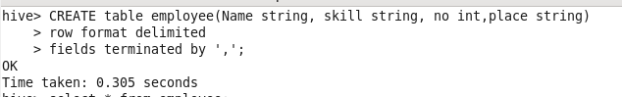

1. Load data into table.

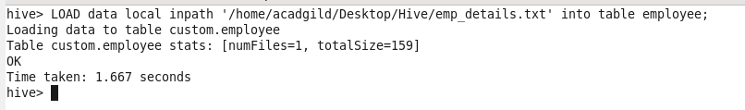

1. Group the data by skill and count the rows for each skills.

